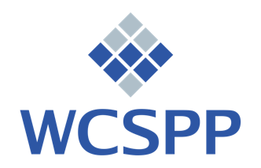

Tuition Assistance Application

WCSPP has a limited Scholarship Fund primarily funded by the generous donations of WCSPP members to support the training of fellow therapists. Awards reduce the cost of tuition and are granted each year. Candidates in multi-year programs need to reapply annually.

Date of Application:

Name:

Program:

Email address:

Please elaborate on the circumstances that constrain the financing of post-graduate training at WCSPP at this time:

Please submit this form and copies of your two most recent federal income tax returns indicating total family income. You may redact your social security number or other sensitive information.

Send to admissions@wcspp.org or, if you prefer, mail to:
WCSPP Administrator
1889 Palmer Avenue, Suite #6
Larchmont, NY 10538

All information will be held in confidence by the WCSPP Directors, Administrator, and
your Program Director.

